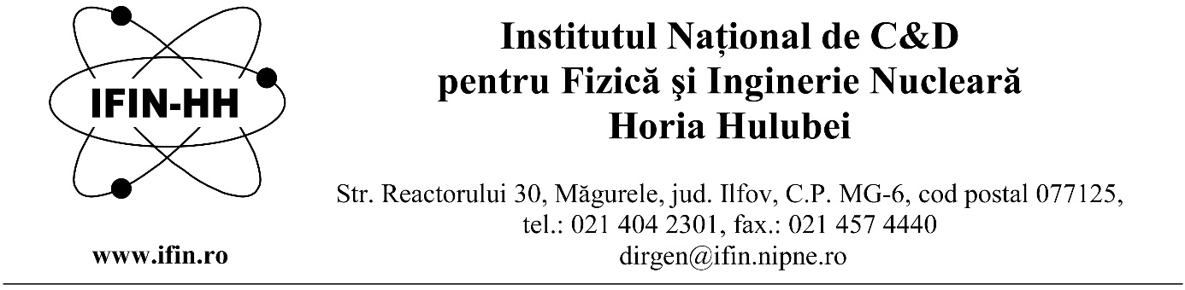
Horia Hulubei National Institute for Research and Development in Physics and Nuclear Engineering is hiring two scientific research assistants for a definite duration, until 30 September 2022, full time, within the Department of Life and Environment Sciences (DFVM).
Two positions of scientific research assistants
Requirements to fill the position:
- Master programme student/graduate, in the fields of: Biochemistry/Biology;
- PC operating skills (word, excel, power point) and specialised programs in the field;
- Foreign languages: English, advanced level (writing and speaking);
- Knowledge of the topics specified in the announcement.

The candidates will be selected according to their previous exposure to lab work(in the laboratories where they have worked before),degree of familiarity with the methodology used in Molecular Biology (extraction and purification of cellular DNA, gel electrophoresis, cloning techniques and PCR) but also according to their firm motivation to work and learn in an experienced laboratory routinely using various modern techniques from the fields of Molecular Biology -Genetics, Biochemistry (expression in bacteria and eukaryotic cells of recombinant enzymes ,their purification by FPLC chromatography and their activity assessment by in vitro tests by spectroscopy and fluorescence) .
Main responsibilities:
- Deepening the knowledge required to fulfil project tasks;
- On-going training and improving in the field of the position topics;
- Participation in the execution of reseach activities foreseen in the contract (automation of the processes, PLC controlled processes, robotic processes, process monitoring and controlled environmental conditions, processing of images obtained by nuclear imaging). The work is to be performed by using open radiation sources;
- Attending the work meetings convened by the project manager;
- Taking part in the data processing and dissemination of the results obtained within the project;

Topics:
- Molecular Biology-Genetics: Molecular Cloning techniques, Genomic sequencing analysis focused mainly on the processes occurring during V(D)J recombination in lymphocytes;
- Biochemistry-Techniques of recombinant proteins expression in prokaryotic and eukaryotic cells, analytical methods required for enzyme catalysis ,fluorescence spectroscopy and liquid flow chromatography(FPLC) , fluorescence spectroscopy in Biochemistry.

Skills and abilities: Ability to work in an organized, hierarchical setting, with rigorous compliance with regulations of the Quality Management System; Motivated, thoroughly, competent person, showing high capacity to be part of a multidisciplinary team, deal with multiple tasks and deadlines, pay attention to details.
Applications will contain the following documents:
- Request for competition registration can be found at www.nipne.ro, specifying the name of the department;

- Copies of the study diplomas and certifications;
- Curriculum Vitae;
- Certificate indicating the capacity of master;
- Copy of the identity document/passport.

The competition will consist of a written test and an interview in the field of the position topics.
The interview can be held only by the candidates who have obtained a minimum score of 7 in the written test.
The candidates who have obtained a minimum score of 7 at the interview are declared admitted. The final score is calculated as arithmetic mean of the scores obtained for the written test and the interview and must be at least 7. The candidate who has obtained the highest score among the candidates competing for the same position is considered admitted, provided that they have obtained the minimum necessary score.

The applications will be sent to e-mail address resum@nipne.ro, until de 11.01.2022.
The written test and the interview will take place on 20.01.2022, at 09:00.
Further information can be obtained by phone 021/404.61.78 or 021/404.23.00 int. 5612/5610.

Bibliography
(for Biochemistry)
1. Donald Voet, JudithG. Voet , Charlotte Pratt, Fundamentals of Biochemistry Life at the Molecular Level, Wiley&Sons ISBN 978-1-118-91840-1, 2011
2. Joseph Lackowicz, Principles of Fluorescence Spectroscopy IIIrd edition, Springer Verlag, 2006, ISBN-10: 0-387-31278-1
Note: Any other source in agreement with our mentioned topics is accepted.

For the interview we would ask the candidates to prepare a powerpoint short presentation of their research (master or licensing disertation) to be presented in front of our committee.
15 min. presentation + 10 min. questions and discussions.

